1. BFS **(19/Apr/2020)**
   1. Print the nodes in the order they are visited

Source Code :

#include<iostream>

using namespace std;

int mat[10][10],i,j,k,n,qu[10],front,rare,v,visit[10],visited[10];

void readgraph()

{

int m;

cout <<"Enter no of vertices:";

cin >> n;

cout <<"Enter no of edges:";

cin >> m;

for(k=1; k<=m; k++)

{

cin >>i>>j;

mat[i][j]=1;

}

cout<<"\n";

cout<<"Adjacency Matrix : \n";

for(i=0;i<n;i++)

{

for(j=0;j<n;j++)

{

cout<<mat[i][j]<<"\t";

}

cout<<endl;

}

}

void bfs()

{

cout<<"\n";

cout <<"Enter Starting node :";

cin >>v;

cout<<"\n";

cout <<"Visitied vertices:";

cout <<v<<" ";

visited[v]=1;

k=1;

while(k<n)

{

for(j=1; j<=n; j++)

if(mat[v][j]!=0 && visited[j]!=1 && visit[j]!=1)

{

visit[j]=1;

qu[rare++]=j;

}

v=qu[front++];

cout<<v <<" ";

k++;

visit[v]=0;

visited[v]=1;

}

}

int main()

{

readgraph();

bfs();

return 0;

}

**OUTPUT**

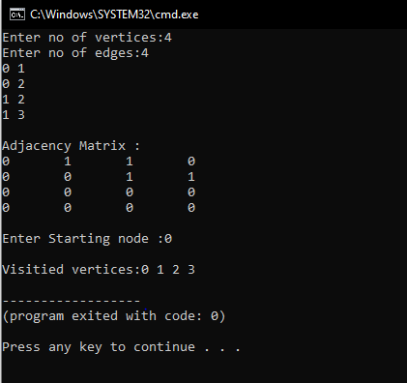

[**https://github.com/harinarayanank/Competitive-Lab**](https://github.com/harinarayanank/Competitive-Lab/tree/master/Sorting%20Algorithms%20Set%201)